**Functional Design Document for Medicare Hub**

**Medicare Hub**

**Project Description:**Medicare Hub is a comprehensive healthcare management system that facilitates seamless interaction between patients and healthcare providers. It incorporates role-based access control with three distinct roles: Admin, Doctor, and User. The system is designed to enhance efficiency in managing appointments, user profiles, and healthcare information.

**Prepared by:** Dhruv Bansal

**Table of Contents**

**1. Project Overview**

* Project Name
* Project Description

**2. Roles and Functionalities**

* 2.1. Admin Role
* 2.2. Doctor Role
* 2.3. User Role

**3. User Interface Design**

* 3.1. Admin Dashboard Interface
* 3.2. Doctor Dashboard Interface
* 3.3. User Dashboard Interface

**4. System Architecture**

* 4.1. Technology Stack
* 4.2. Data Flow

**5. Functional Requirements**

* 5.1. Role Management
* 5.2. Appointment Handling
* 5.3. Profile Management
* 5.4. Department Management

**6. Non-Functional Requirements**

* 6.1. Security
* 6.2. Scalability
* 6.3. Performance
* 6.4. Usability

**7. Conclusion**

**1. Project Overview**

**Project Name: Medicare Hub**

**Project Description:**

Medicare Hub is a healthcare management system with role-based access control. It includes three main roles: Admin, Doctor, and User. Each role has distinct functionalities that allow users to manage appointments, view lists (patients, doctors, departments), and maintain profiles. The system is designed to streamline the interaction between patients and healthcare providers.

**2. Roles and Functionalities**

**2.1. Admin Role**

**Dashboard:**

The Admin Dashboard is the central control panel where the admin can access various functionalities.

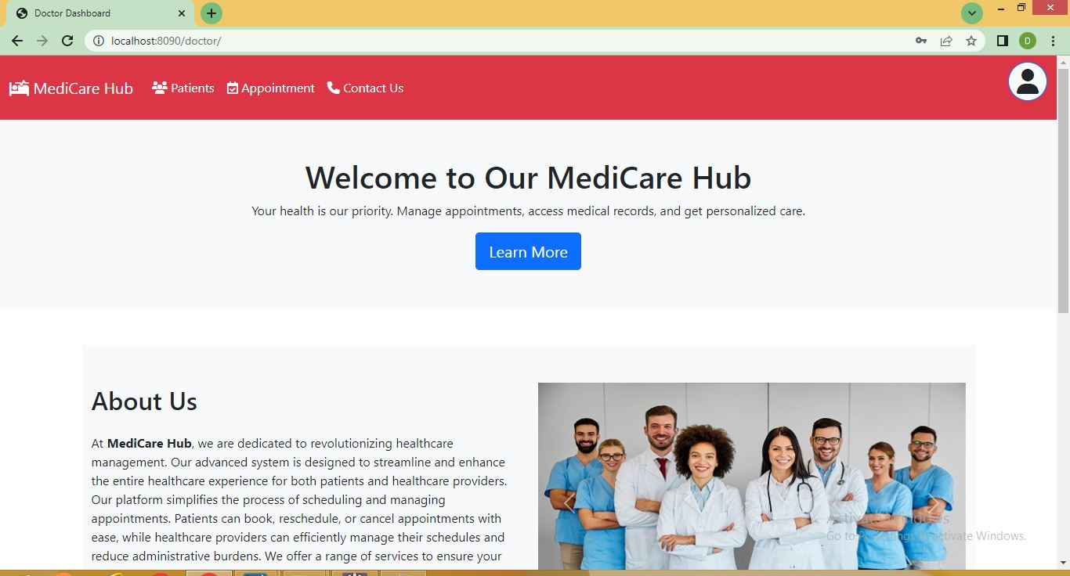

- Manage User Roles:

- Assign roles to users (Admin, Doctor, User).

- Update or change user roles as required.

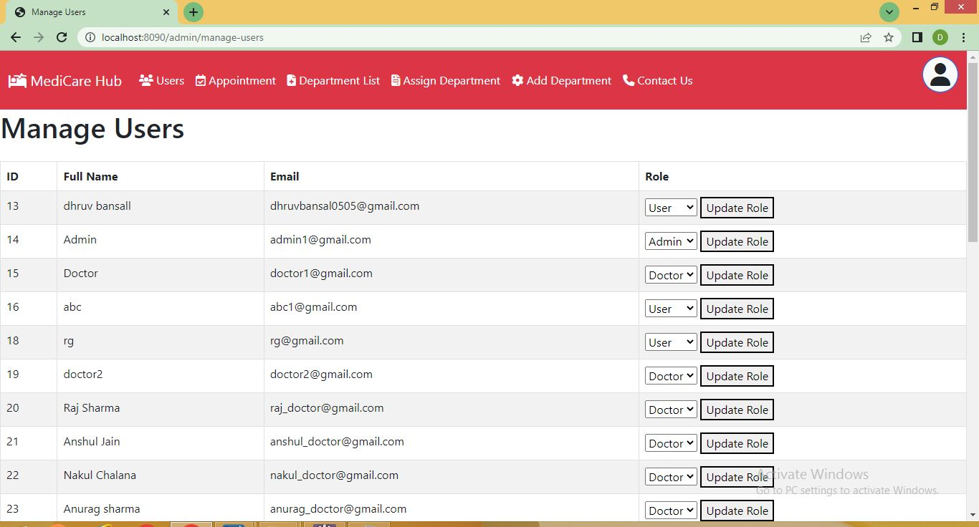

**Patient List:**

- View a list of all patients registered in the system.

- Access patient details (e.g., name, contact info, appointment history).

**Doctor List:**

- View a list of all doctors registered in the system.

- Access doctor details (e.g., name, specialization, department).

**Appointments List:**

- View all appointments that have been approved by doctors.

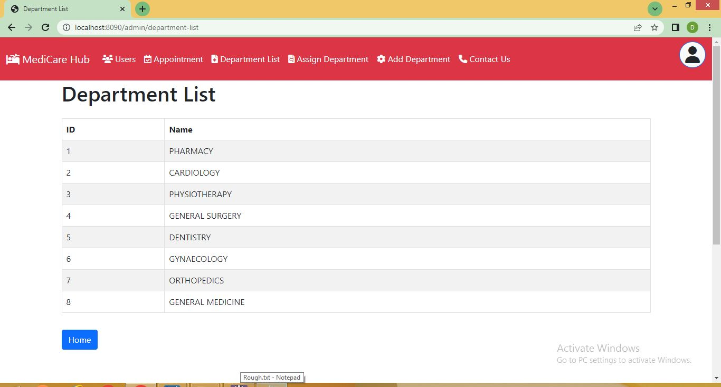

**Department Management:**

- View the list of departments within the hospital.

- Add new departments to the system.

- Assign departments to specific doctors.



**Profile Management**:

- View the admin profile.

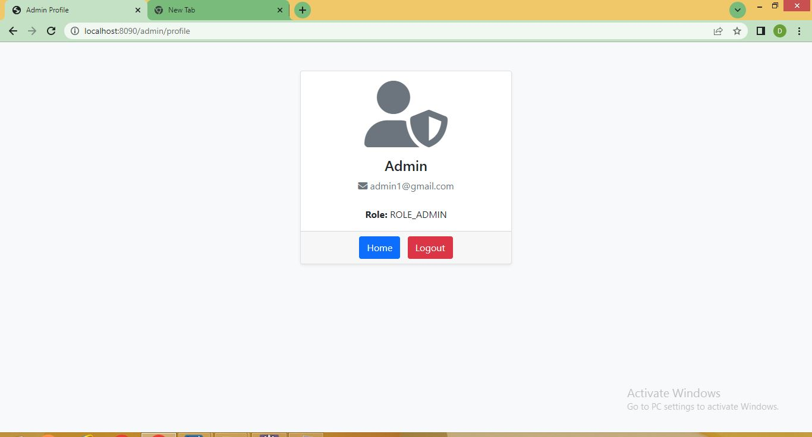

**2.2. Doctor Role**

**Dashboard:**

- The Doctor Dashboard provides an overview of the doctor’s appointments and patient list.



**Manage Appointments:**

- View appointment requests from users.

- Approve or reject appointment requests.

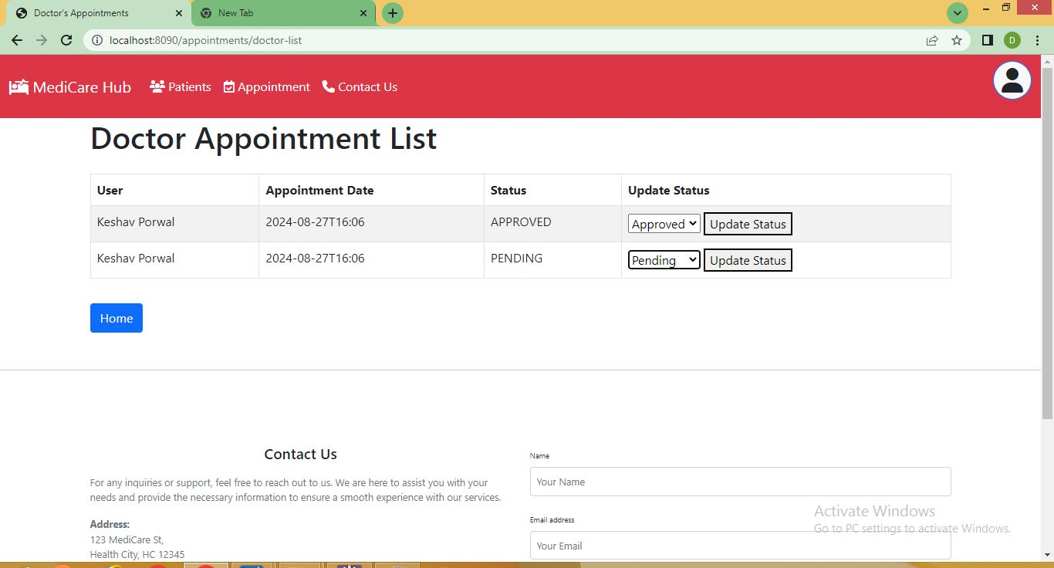

**Patient List:**

- View a list of patients assigned to the doctor.

- Access patient details.

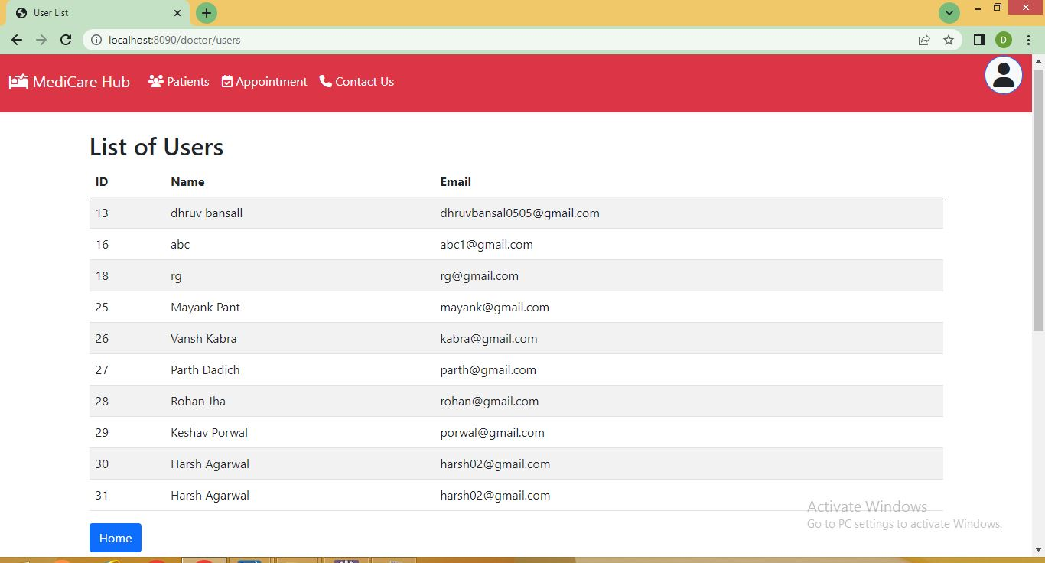

**Profile Management:**

- View and update the doctor profile (e.g., name, contact info, specialization, password).

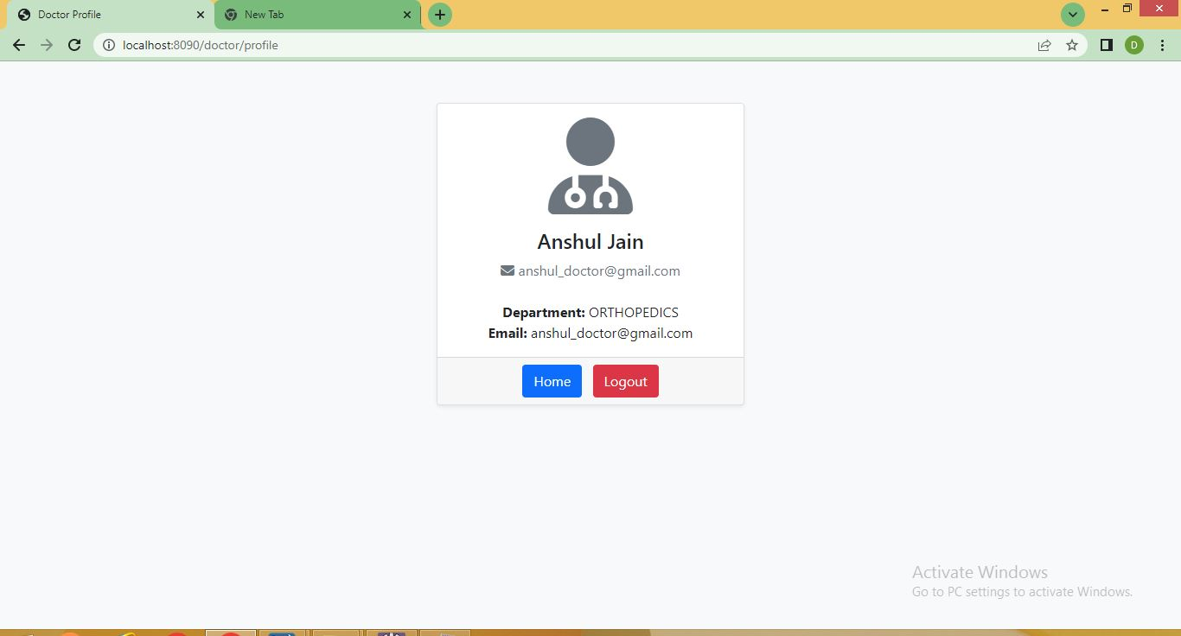

**2.3. User Role**

**Dashboard:**

- The User Dashboard allows users to manage their interactions with the healthcare system.

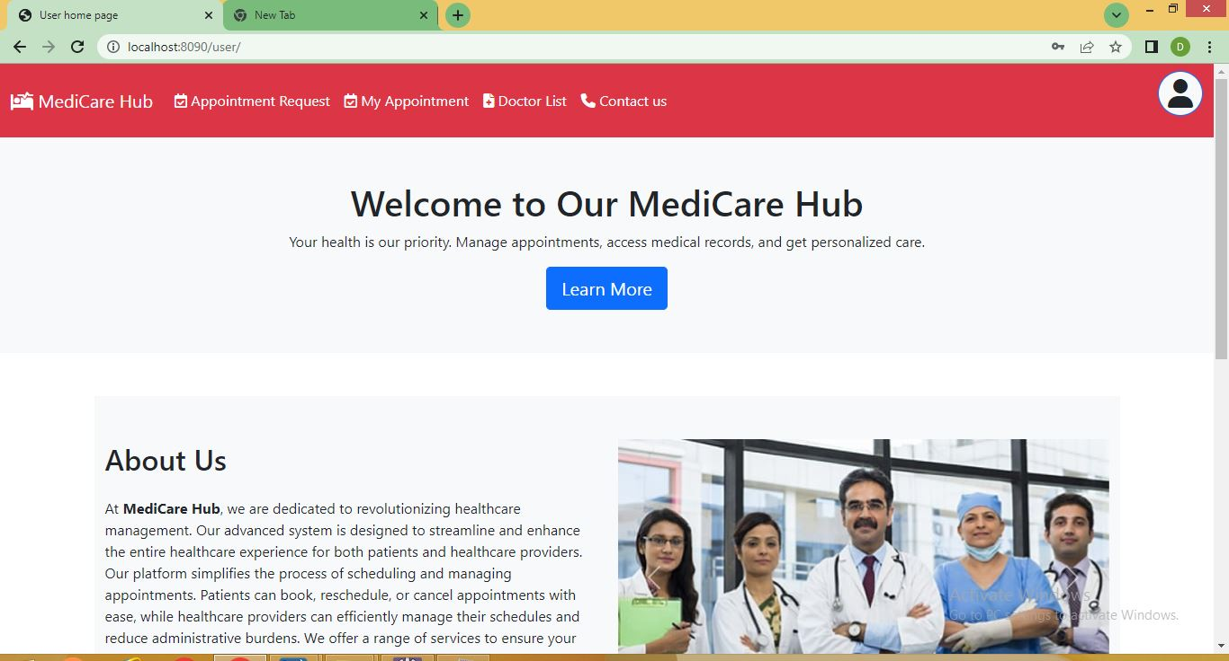

**Request Appointment:**

- Submit a request for an appointment with a doctor.

- Select the department and doctor for the appointment.

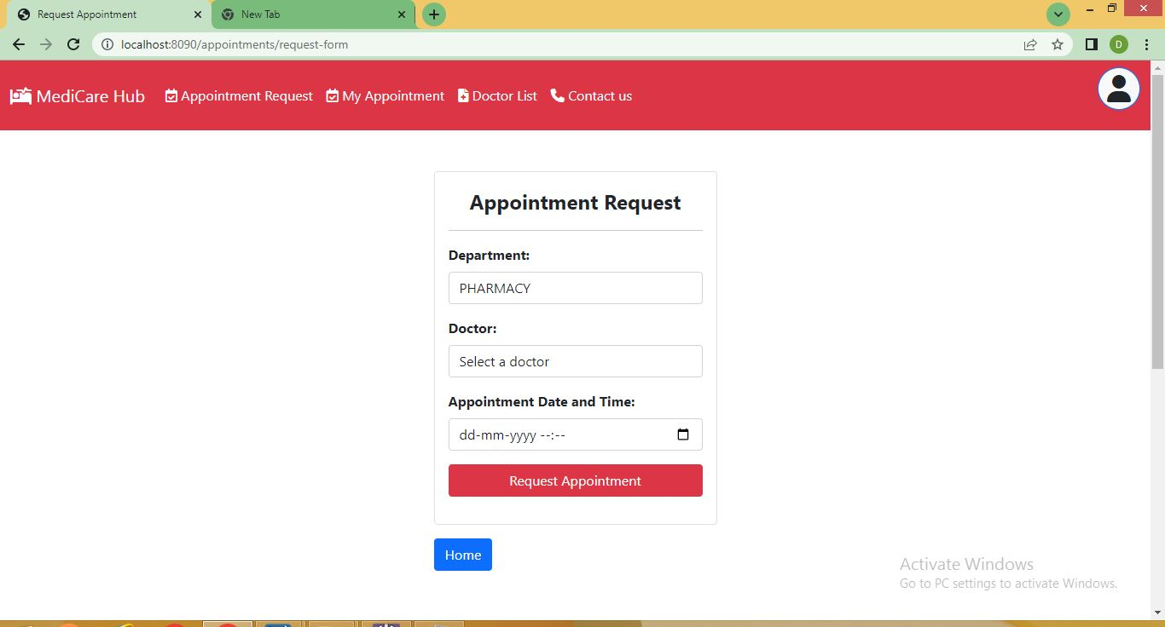

**Appointment Status:**

- View the status of submitted appointments (e.g., pending, approved, rejected).

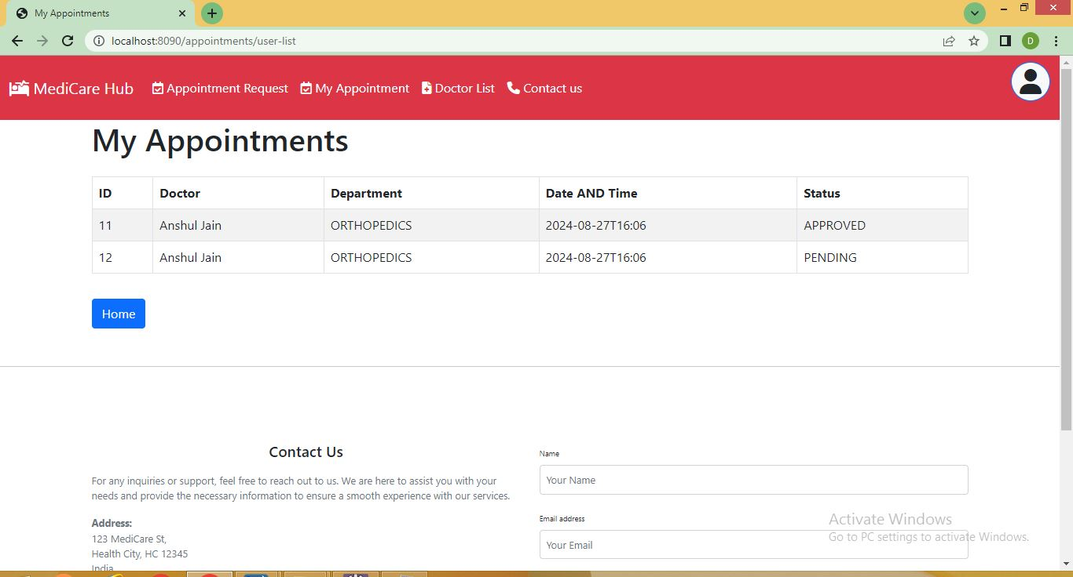

**Doctor List:**

- View a list of doctors in the system.

- Filter doctors by department or specialization.

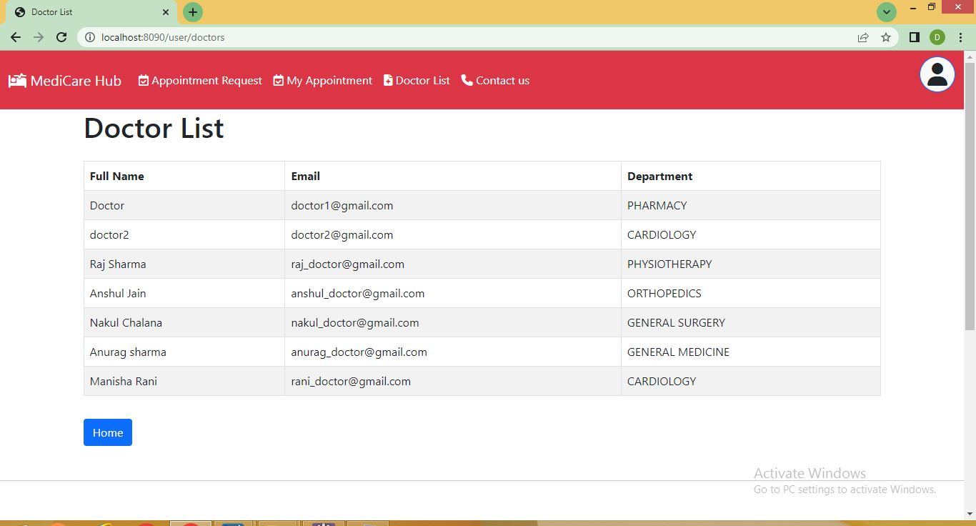

**Profile Management:**

- View and update the user profile (e.g., name, contact info, password).

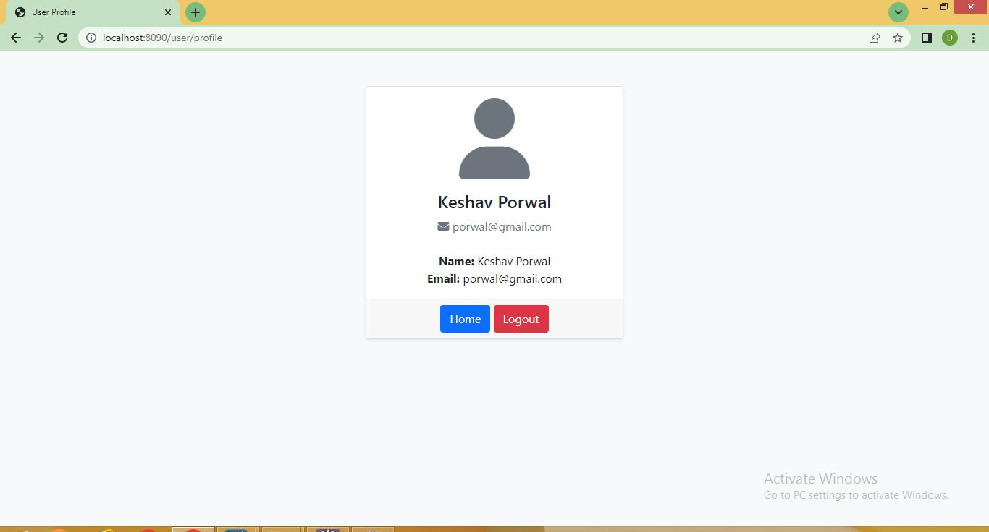

**3. User Interface Design**

**3.1. Admin Dashboard Interface**

- **Navigation Menu:** Access to manage users, patients, doctors, departments, appointments, and profile.

- **Main Panel:** Displays overview and statistics related to users, appointments, and departments.

**3.2. Doctor Dashboard Interface**

- **Navigation Menu:** Access to manage appointments, view patient list, and profile.

- **Main Panel:** Displays upcoming appointments and patient overview.

**3.3. User Dashboard Interface**

- **Navigation Menu:** Access to request appointments, view appointment status, view doctor list, and profile.

- **Main Panel:** Displays appointment history and available doctors.

**4. System Architecture**

**4.1. Technology Stack**

- **Frontend:** HTML, CSS, JavaScript

- **Backend:** Java, Spring Boot

- **Database:** MySQL/SQL Database

- **Security:** Spring Security for role-based authentication and authorization

**4.2. Data Flow**

- **User Authentication:**

Users log in through a common login interface. Based on their credentials, they are redirected to the appropriate dashboard (Admin, Doctor, User).

- **Role-Based Access:**

Each role has specific endpoints and functionalities that are secured using Spring Security.

- **Database Management:**

Data related to users, appointments, doctors, and departments are stored in a relational database. CRUD operations are managed through the backend services.

**5. Functional Requirements**

**5.1. Role Management**

- Admin can assign and modify user roles.

**5.2. Appointment Handling**

- Users can request appointments.

- Doctors can approve/reject appointments.

- Admin can view all approved appointments.

**5.3. Profile Management**

- Each role can view and update their profile details.

**5.4. Department Management**

- Admin can manage departments and assign them to doctors.

**6. Non-Functional Requirements**

**6.1. Security**

- Role-based access control ensures that users can only access the functionalities specific to their role.

- Passwords and sensitive data are encrypted in the database.

**6.2. Scalability**

- The system is designed to handle a growing number of users, doctors, and appointments without performance degradation.

**6.3. Performance**

- Efficient data handling ensures quick response times for dashboard interactions.

**6.4. Usability**

- The user interface is intuitive, making it easy for all users to navigate and perform their respective tasks.

**7. Conclusion**

This document outlines the functional design of the Medicare Hub project, detailing the roles, features, and system architecture. The system is designed to provide a seamless experience for users, doctors, and admins, ensuring efficient management of healthcare services.